E-Commerce Client Boosts Keywords 764%
SEO Case Study
E-commerce Industry

E-commerce retail orders experienced a 129% year-over-year growth last April in the United States and Canada. It’s safe to say that we’re entering a new era of e-commerce.

More customers are enjoying the ease and convenience of shopping online. This trend coupled with the COVID-19 pandemic has fueled tremendous growth in e-commerce operations.

If you’re running an online store or if you have plans to open one, you need to think seriously about your SEO. A good strategy could rank you on the first page of Google and bring thousands of new visitors to your site each day.

Keep reading below to learn how we helped an e-commerce store increase its ranking keywords by 764% and bring in around 10,000 monthly website visitors.

Background
A specialized e-commerce company reached out to us at the end of 2019 for assistance with their SEO. Their online store offers super-absorbent hair towels. The same material is also available for sale as headbands, pillowcases, and shower caps.

This client launched its website in 2015 and had achieved some moderate traffic gains before reaching out. The problem was they couldn’t surpass 3,000 monthly visitors.

More web traffic means more eyes on inventory. We knew this company wanted to increase its online sales. But, first, we had to boost their SEO so more people were visiting their e-commerce store.

Our team started off by conducting a comprehensive SEO audit of their site. We do this for every client.

The SEO Audit
Before we could increase the number of visitors, we had to understand what was going on with their traffic, keywords, and backlinks.

The audit confirmed that the company’s traffic was flat. They would experience the occasional increase but it will drop shortly afterward. This seesaw trend had been happening for at least a year before they started working with us.

Web traffic hovered at about 2,000 visitors per month when they signed up with us in November 2019. Furthermore, they were only ranking for 1,650 keywords and their site had 170 referring domains (the number of external websites linking to them)

Our SEO team knew that in order to help this client we’d have to improve their search ranking by optimizing their keywords and gaining more backlinks. The first step was to determine our “easy win” keywords.

Finding “Easy Wins” Through Keyword Research
What are “easy win” keywords?

These are keywords that a client is already ranking for in positions 4-30. With a few adjustments, these keywords can be incorporated into the client’s website and boost their ranking. It’s a quick and easy way to help them right out of the gate.

We found that this client was ranking for nearly 6,000 “easy win” keywords in the United States alone. They also sold products to many customers in Australia, Canada, and the United Kingdom.

Once we identified all of these keywords, our next step was to find “easy win” keywords with a high search volume. For example, the keywords “hair bands” were in position seven yet had 14,000 searches per month.

Another example was “satin vs silk.” It was in position three and had a search volume of 4,400.

How do we get these keywords to start working for a client? After figuring out what they are, our writing team can incorporate these keywords into your web copy, blogs, or other ranked content.

Competitive Gap Analysis
It’s around this point in the process when we start crafting our SEO strategy.

As part of our marketing research, we’ll also run a competitive gap analysis. The purpose of this is to find out what the client’s main competitors are doing and what we can incorporate into our strategy.

The competitive gap analysis involves keywords. Not everything a competitor is doing would be relevant to our client, but we want to make sure that we aren’t missing any opportunities.

We learned that our client had 43 online competitors. Some of these competitors were very similar to them, while the rest may have offered a few comparable products in their inventory.

For this analysis, we looked at their No. 1 competitor. While they both shared approximately 800 keywords, the competitor ranked for an additional 3,638 unique keywords.

These are keywords that our client wasn’t ranking for. As a result, our SEO team sifted through this list and found keywords that could work for them.

The SEO Campaign
In the very beginning, this e-commerce client started using us for content syndication. A month later we convinced them to sign up for our managed SEO service.

Our expert team takes care of everything so business owners can focus on developing their operations. Clients can be as hands-on or hands-off as they wish, and they receive regular analytics reports.

We conferred with the client and decided that it was best to focus on content and gaining more backlinks.

Here are the products we used for their campaign:

- Guest Posts
- Blogs
- Link Building
- Content Syndication

We helped beef up the client’s content with a number of SEO-optimized blogs and earned them a few more backlinks with guest posts.

Our content syndication service was a great way for them to distribute their valuable content to high-authority news sites. Clients who take advantage of this product often receive media coverage that can be used as social proof on their websites.

Results
First, let’s take a look at the client’s traffic. We explained above how they never seemed to gain traction. After working with us for a year their traffic jumped to around 10,000 visitors per month.

Our team was able to increase their traffic so dramatically by optimizing their keywords and producing more quality content.

As you can see below, we increased their number of organic keywords from 1,650 to 14,254 today. That’s a 764% increase in keywords!

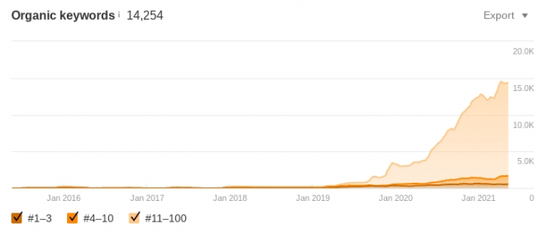

Many of these new ranking keywords were some of the “easy wins” we incorporated into their strategy. Others were a result of our comprehensive SEO strategy. You can also see that their position 1-3 rankings more than doubled.

The last part of our strategy was getting more backlinks.

We stated earlier that the client had 170 referring domains when they started working with us. Over the next year the number of websites linking to our client ballooned and today they have approximately 400 referring domains.

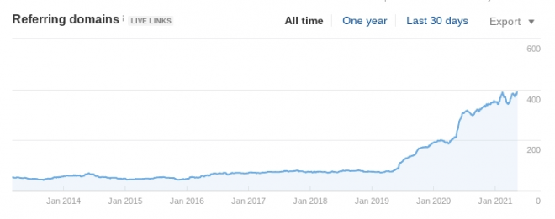

Backlinks are arguably the most effective way to boost your SEO ranking.

We knew this campaign was effective once we saw the number of high-authority sites linking to our client.

Conclusion
Every client is different just like every SEO campaign. In this case, we coordinated with the client and determined that focusing on content and link building would be the best way to proceed.

Luckily, the client signed up with us. We offered them a variety of SEO services to improve their rankings.

It often takes more than one tool to get a company’s SEO up and running.

Do you have any specific questions about our services or how we helped this e-commerce client? Book a call with us! We would love to chat about your business and goals.

