Helping an E-Commerce Client Hit 25,000 Monthly Visitors
SEO Case Study
E-commerce Industry
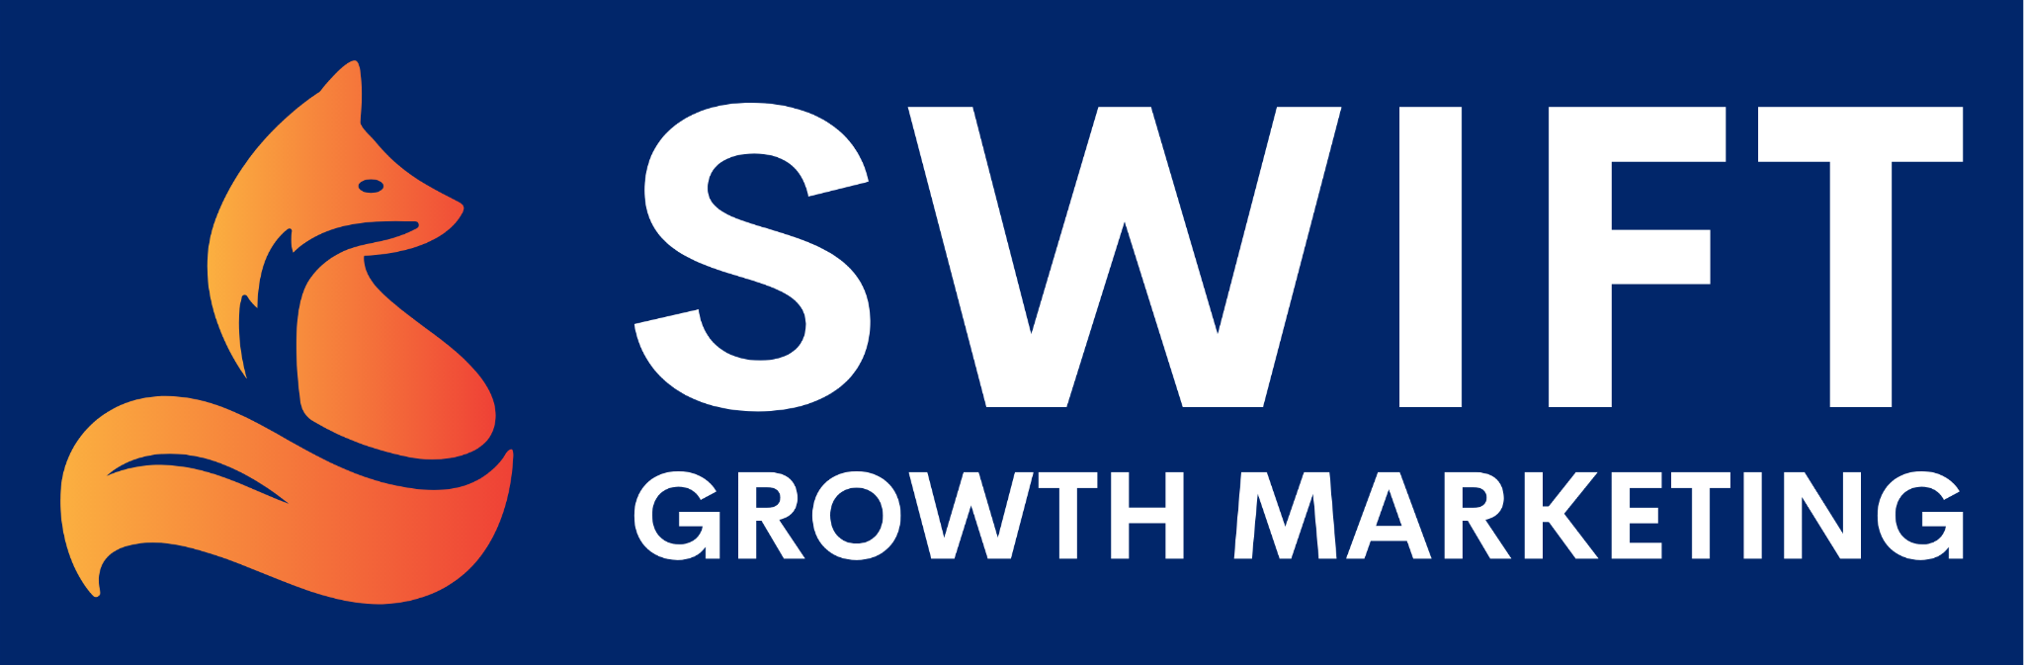

Are you the owner of a new or well-established website looking for more traffic? E-commerce businesses live or die by the number of people visiting their sites.

You may want more conversions but that won’t happen unless you get more eyes on your products, promotions, or landing pages.

We wrote this case study to show you how an e-commerce client more than doubled their traffic by using our managed SEO service. Keep reading below to learn how we did it and how our product makes it easy for you to do the same.

Background
An online provider of premium men’s and women’s fragrances in the United Kingdom reached out to us in June 2020. The company stocks thousands of the most popular high-street fragrances and is constantly updating its inventory.

They reached out to us wanting to boost their online presence to get more sales. It was clear that this e-commerce business was entirely dependent on people visiting their site. Therefore, we would start by using our SEO mojo to increase their organic traffic.

This company was already on its way to getting more online visitors. We knew we could help by optimizing their keywords and setting up more links.

The SEO Audit
Our first step in working with this client was doing a complete audit of their site. As mentioned above, the company was already employing some effective SEO strategies. They just needed our expertise to reach the next level.

We learned that their organic traffic was around 8,000 visitors per month when they first signed up with us. Their traffic had been trending upwards since the beginning of 2020.

Links are one of the best ways to increase traffic and SEO ranking. During the audit, we found that they only had about 50 links at the beginning of June 2020. Our marketing experts knew that they needed more links.

The “Easy Wins” Keyword Analysis
After the SEO audit, we can quickly influence a client’s traffic by optimizing “easy win” keywords on their website. These are keywords they aren’t currently ranking for in the 4-30 positions.

It turns out the company had over 5,000 “easy win” keywords to choose from. We wouldn’t use them all, but instead find ones that could help us quickly boost ranking and traffic.

Our goal was to select “easy win” keywords with high search volume (the number of people using the keyword in a search) but with a low keyword difficulty (how hard it would be to rank with these keywords from 0-100).

A keyword like “fragrance direct,” for example, has a KD of 12 out of 100, but 123,000 searches. Other “easy wins” included “ghost perfume,” “aftershave,” and “dior sauvage.”

We took these keywords and incorporated them into web copy, blogs, or other content that could help the client to get more exposure.

Don’t think we forgot about keywords ranking in the 1-3 positions. Our goal is to get these as well but that process takes longer.

Competitive Gap Analysis
Business owners understand how important it is to do competitive research. You need to know your competitor’s strengths, weaknesses, and the unique things they’re doing that you could also benefit from.

In no way is this designed for you to do the exact same thing as your biggest competitor. Rather you want to identify opportunities that would also fit your business. Not everything your competitor is doing would work for you.

The competitive gap analysis involves using sophisticated digital tools to see what keywords are helping your competitor. They may be keywords you could add to your strategy!

We found that the company had 47 competitors in the United Kingdom. Although the field was crowded, we knew many of these businesses were probably using the same keywords.

One competing business shared 39% of our client’s keywords. But, upon further review, we saw that the competitor also ranked for an additional 5,116 keywords.

The SEO Campaign
Next came the exciting part. This client signed up for our best-selling managed SEO service.

The benefit of our managed service is we take everything off a client’s plate. That way they can focus on developing their business while we take care of the digital marketing.

Another huge benefit is that clients get access to all of our products and services. They’re assigned a dedicated campaign manager who can utilize anything from link-building outreach to content syndication. Having access to all of these products helps campaign managers to individualize client strategies.

Monthly orders for this client consisted of:

- Blogs
- Guest Posts
- Link Building

The blogs helped build up the client’s ranked keywords, while for guest posts we focused on sites with higher domain authority.

The quantity of each order may have shifted from month to month based on a number of variables, but the strategy remained consistent.

It’s important to understand that getting the results you want could take three months or more. Patience is key.

Results
Our favorite part of any campaign is sharing the incredible results with our clients. First, let’s take a look at the company’s growth in organic traffic.

In nine months from when they first contacted us in June 2020, their traffic spiked from 8,000 visitors per month to 24,791 today.

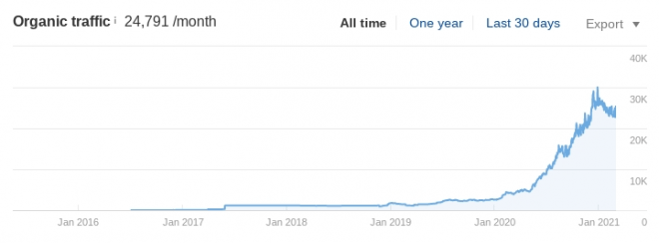

Wondering how much that traffic is worth? Today, their traffic is valued at $9,331. This means they would have to spend this much to get the same amount of paid ad traffic.

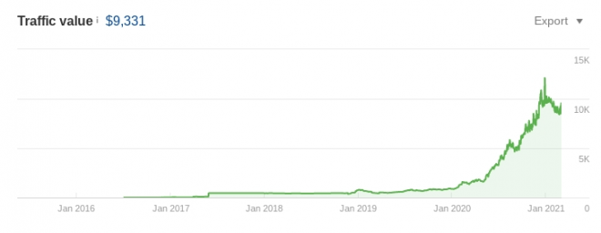

As you probably noticed in our strategy, our goal was to set up more links for the client.

In the end, we increased the number of backlinks from 50 in June 2020 to over 200 in the new year. That’s a 300% increase in seven months!

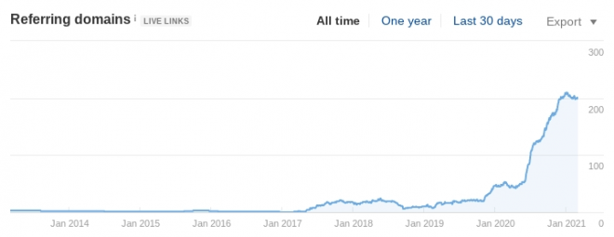

This client really stuck it out and is now experiencing a surge in-store visits and sales. It took them longer than the average three months to get these big results but they trusted us and it paid off in the end.

Conclusion
Every e-commerce store needs to work on its SEO consistently. The company knew they didn’t have the time or resources to continue optimizing their SEO at an elite level.

Our experienced campaign managers used every tool at their disposal to increase online traffic.

We offer a range of SEO and PPC products for all needs.

Clients who like our managed SEO service can also enroll in a program to have us take the reins on their paid ads. We have PPC experts capable of maximizing your sales and leads.

So, what are you waiting for? Reach out to our digital marketing experts to find out how we can help boost your online presence.

