Local Business Explodes Traffic From 400 to 45,000
SEO Case Study
Swimming Pool Industry
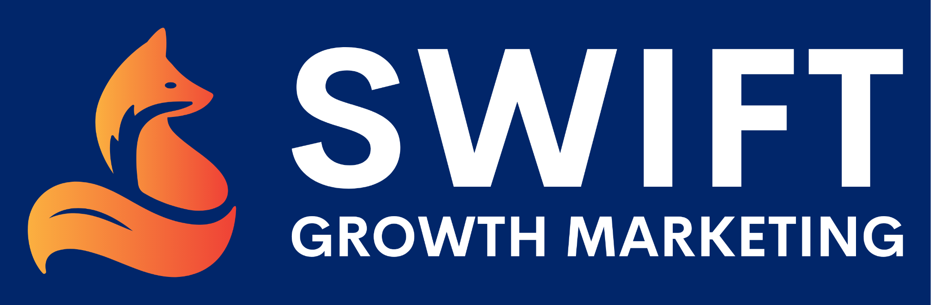

In this case study, we’ll take you step-by-step on how we helped a Midwest-based pool and spa company increase their website traffic from 400 to 45,000 visitors per month.
Our agency used advanced SEO techniques and strategies to put them ahead of the competition. Keep reading to learn what we did for this growing pool and spa retailer.

Background
A pool and spa company reached out to us at the end of June 2019 with a request to expand their online presence. They are a premier pool and spa provider with one showroom based in the Midwest.
But, the company’s website also helps to educate and inform customers throughout the entire country.
They asked us to utilize targeted keywords and high-quality content to increase the sales of spas, above ground pools, saunas, endless pool fitness systems, and inground pools. We recommended that they enroll in our managed SEO program.

The SEO Audit
Whenever a new client joins us, our first step is to do a comprehensive audit of their website to know what we’re working with.
The pool and spa company first signed up for our managed service in June 2019 when their organic traffic was about 400 visitors per month and they were ranking for a little over 2,000 keywords. This was a good start but it was clear more SEO work needed to be done.

“Easy Win” Keywords Analysis
Once we’ve audited a client’s website we can begin helping their SEO immediately by targeting “easy win” keywords.
These are keywords the client is already ranking for in SERP positions 4-30. These are keywords that Google already likes and recognizes, and by building more content and links around them, we can boost them up the rankings.
We learned that the pool and spa company was already ranking for over 1,200 of these “easy win” keywords, ranging from “resin vs steel above ground pools” in a more competitive position to “sauna fitness” on the other end of the spectrum.
Even more encouraging was how many of them had a low keyword difficulty or KD ranking. This tells us how difficult it would be for the keyword to rank in the top 10 of search results.

Competitive Gap Analysis
Before unrolling our individualized SEO strategy, we must also understand what competitor websites are doing online. These include regional and national retail websites selling pools or saunas.
Rather than doing an apples to apples comparison of keywords used, our goal with a competitive gap analysis is to identify new opportunities with keywords that are relevant to our client’s business. For example, this particular client shared 1,000 keywords with its largest online competitor. But, their competitor ranked for an additional 3,000 unique keywords.
We explored this extensive list to find new keywords we could incorporate into our strategy. One way of doing this is by writing blog posts featuring that topic and keyword.

SEO Strategy & Execution
Our strategy with the pool and spa company was to begin incorporating more high-performing organic keywords like “above ground pool” and “infrared vs. traditional sauna.” We knew this would be difficult because they’re very competitive, but we were confident our efforts would pay off in the end.
Here are other services we provided:
- Link building
- Guest posts
- Blogs
Our efforts brought in-content links back to their site. Backlinks are one of the most powerful ways to boost your SEO. DA (Domain Authority) runs from zero to 100. The higher the number, the more authoritative the site.
And blogs helped provide high-quality content to their visitors while simultaneously ranking for new keywords. Their most popular blog post was titled “Dive Into This Above Ground Pool Guide.” It described all of the above ground pool options available to customers and was responsible for a ton of organic traffic.

Campaign Results
The pool and spa company started working with us in 2019 and we made steady gains that year. But, it wasn’t until September 2020 when their traffic finally exploded.
As you can see below, their organic traffic tripled in September 2020 and has continued to increase into the new year. They now receive 45,000 visitors each month.
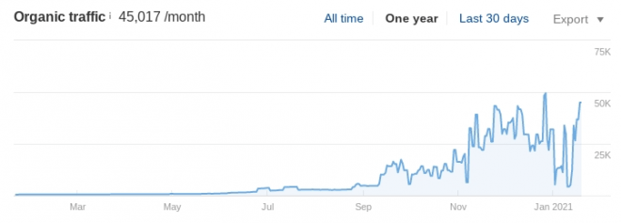
Early in the process of working with us, the pool and spa company requested an increase in ranking keywords. As you can see below, their organic keywords increased steadily throughout the end of 2020.
A majority of the increases were considered “easy wins” yet the number of ranked keywords in the No. 1-3 positions increased from approximately 230 in September to 360 today.
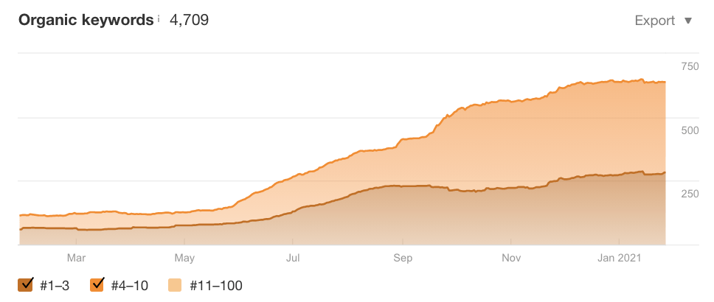
And, of course, one of the most exciting metrics for any business is the value of their organic traffic. This is the amount they would have to spend on paid advertising to get the same exposure.
Their traffic value jumped from $7,000 in September 2020 to $73,000 today.
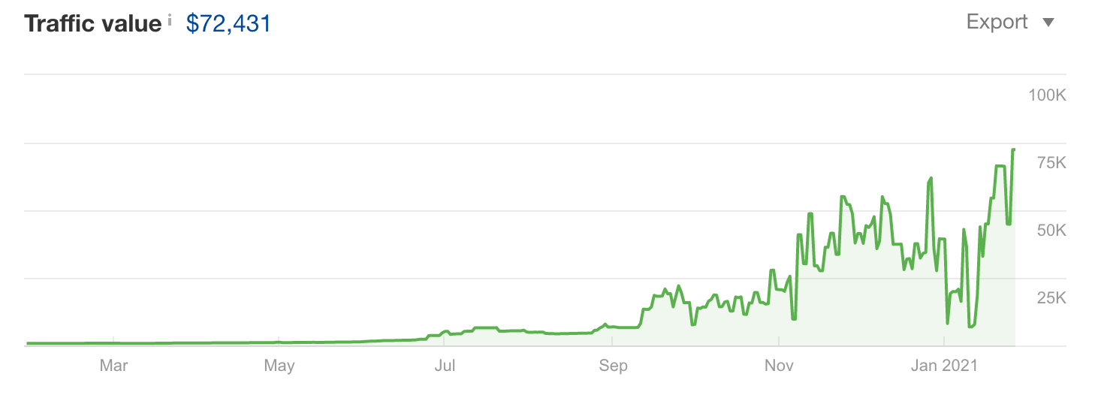
What happened next was proof that our strategies worked for them. The company reached out to us and said they were getting too many calls and leads from around the country! Talk about good problems!
Even though their phone lines were being flooded, we helped them set up arrangements with other national companies where they could sell leads or gain referral payments. No matter what develops along the way, we try to make it work for our clients.

Takeaway
There are multiple reasons that this pool and spa company experienced such success with us. First, they enrolled in our managed SEO program, providing them with a dedicated campaign manager and access to all of the digital tools. This allowed us to customize their winning SEO strategy.
Patience and persistence were the other reasons for their impressive growth. Building up ranked keywords, links, and new content takes time. There is no guidebook about how long it takes for SEO efforts to finally kick-in. Our SEO strategies are unique to each client.
We tell clients it could take three to six months to see the fruits of our labor, but for others, it could take longer. The point is you need to be patient and persistent to ensure you don’t miss out on the big payout.
Want to learn more about how we can help you get more traffic to your website? Schedule a call with one of our digital marketing experts today!

